**Activity based**

**Project Report on**

**Computer Network**

**Submitted to Vishwakarma University, Pune**

**Under the Initiative of**

**Contemporary Curriculum, Pedagogy, and Practice (C2P2)**

**By**

**Alfiya Sayyed**

**SRN No: 202202232**

**Roll No: 51**

**Div: F**

**Third Year Engineering**

**Project Report: 01**

**Department of Computer Engineering**

**Faculty of Science and Technology**

**Academic Year**

**2024-2025**

**Design and Implementation of a Local Area Network (LAN) for a Specific Location**

**Project Statement:**

Design and implement a Local Area Network (LAN) for a specified location, such as a school, office building, or community center. The project involves identifying optimal spots for network devices (switches, routers, and access points), configuring the network with appropriate IP addresses, establishing communication between different sub-networks, and calculating the overall cost of network development. This project aims to provide students with hands-on experience in network design, configuration, and cost analysis.

**Project Objective:** To understand development stages in Local Area Network

**Project Outcome:** Student can develop Local Area Network and perform cost analysis of Network Infrastructure.

**Theory:**

The design and implementation of a Local Area Network (LAN) involve several crucial steps to ensure effective communication, connectivity, and performance within a specified location such as an office building. The project primarily focuses on establishing a well-structured network with optimal placement of devices and proper configuration for smooth and secure data transmission.

The **network design** process starts with creating a topology, which involves determining the layout of network devices such as switches, routers, access points, and servers. This topology ensures that all departments and sections of the organization are well-connected, supporting both wired and wireless communication.

Key concepts like **IP addressing** and **subnetting** are applied to organize the network into segments (VLANs) that separate different departments or functional areas. This helps manage traffic efficiently, improves security by isolating sensitive departments, and allows for better control over resource allocation.

Additionally, **redundancy** is a vital consideration in network design, ensuring that there are backup paths and devices like firewalls and multiple routers in case of device failure. By doing this, the network remains operational, minimizing downtime and disruption to business activities.

**Cost analysis** also plays a critical role in network development. It involves calculating the expenses for hardware, such as routers, switches, access points, and cabling, as well as labor costs for installation. This helps in budgeting and choosing the most cost-effective solutions without compromising on performance and security.

In conclusion, a well-designed LAN not only provides the necessary infrastructure for communication but also ensures scalability, security, and cost-efficiency, enabling an organization to run smoothly with optimal network performance.

**Site Survey:**

**A detailed report documenting the site survey findings, including the physical layout and identified spots for network devices.**

**1. Site Survey:**

For the BSNL office, the site survey plays a critical role in ensuring optimal network design and device placement. Here’s a breakdown of the survey process based on the provided network topology:

* **Documenting the Physical Layout:**
  + The BSNL office is organized across three floors:
    - **First Floor:** This floor includes departments such as Sales & Marketing (VLAN 10), HR & Logistics (VLAN 20), and Finance & Accounts (VLAN 30).
    - **Second Floor:** Departments here include Admin & Public Relations (VLAN 40) and ICT (VLAN 50).
    - **Third Floor:** The third floor is dedicated to the Server Room (VLAN 60), which houses critical network infrastructure such as Email Servers, DNS Servers, and DHCP Servers.
* **Identifying Optimal Spots for Network Devices:**
  + **Core Routers and Switches:**
    - **Core Routers (2911 and 2911):** Positioned centrally between floors, allowing for high availability and redundancy. These routers are configured to manage traffic between sub-networks and external connections (OSPF configuration is used for routing).
    - **Multi-layer Switches (3560):** These switches are connected to the core routers to route traffic between VLANs, ensuring efficient communication between different departments across the network.
  + **Firewall:** The firewall is strategically placed between the external network and internal systems, providing a crucial layer of security for BSNL’s internal communications.
  + **Access Points (APs):** Wireless Access Points are located on each floor, specifically in departments like Sales & Marketing and ICT, ensuring full Wi-Fi coverage for wireless devices such as laptops and tablets.
* **Physical Environment Considerations:**
  + The network diagram clearly shows the placement of all network devices on each floor, indicating efficient use of space and cabling for better performance and maintenance. While GPS-tagged photos would be useful for large physical spaces, in this scenario, the network topology diagram sufficiently covers the surveyed layout.

**GPS tagged photo of site**

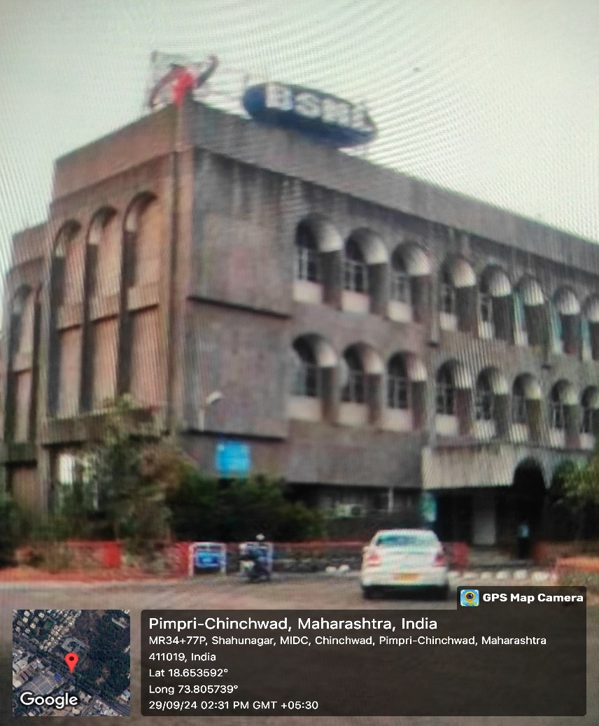

**Network Design Implementation:**

Use network design software such as **Cisco Packet Tracer or Visio** to create a detailed topology diagram for the BSNL office.

**A. Network Topology Design:**

* **Routers:** Place core routers in a centralized data center or server room.
* **Switches:** Deploy switches on each floor for departments like Sales, Admin, IT, HR, etc.
* **Access Points:** Strategically place wireless access points to provide Wi-Fi connectivity for mobile users.
* **Firewall:** Implement a firewall between external networks and the internal BSNL LAN for security.

**B. Logical Network Design:**

* **VLAN Configuration:** Set up VLANs for each department (e.g., Sales & Marketing, HR, Finance, Admin, IT, etc.).
  + Sales: VLAN 10 (e.g., IP Range: 172.18.10.0/25)
  + HR: VLAN 20 (e.g., IP Range: 172.18.11.0/25)
  + Finance: VLAN 30 (e.g., IP Range: 172.18.12.0/25)
  + Admin: VLAN 40 (e.g., IP Range: 172.18.13.0/25)
  + IT: VLAN 50 (e.g., IP Range: 172.18.3.0/25)
  + Server Room: VLAN 60 (e.g., IP Range: 172.18.3.128/28)

**C. IP Addressing Scheme:**

* Use an IP addressing scheme with subnetting for efficient allocation of IP addresses to each department.
  + **Subnet:** 172.18.0.0/16
  + **Core Routers**: Use /30 subnets for point-to-point links between routers.
  + **Access Points**: Assign IP addresses from each respective VLAN range for wireless devices.

**D. Network Devices:**

* **Router:** Cisco ISR 2900 Series (or similar) for core routing.
* **Switches:** Cisco Catalyst 2960-X Series for department-level switching.
* **Firewall:** Implement a firewall for securing external and internal traffic.
* **Access Points:** Cisco Aironet 1800 Series for wireless access.

**E. Implementation Steps:**

1. Basic settings to all devices plus ssh on the routers and 13 switches.

2. VLANs assignment plus all access and trunk ports on 12 and 13 switches.

3. Switchport security to finance department.

4. Subnetting and IP addressing

5. OSPF on the routers and 13 switches.

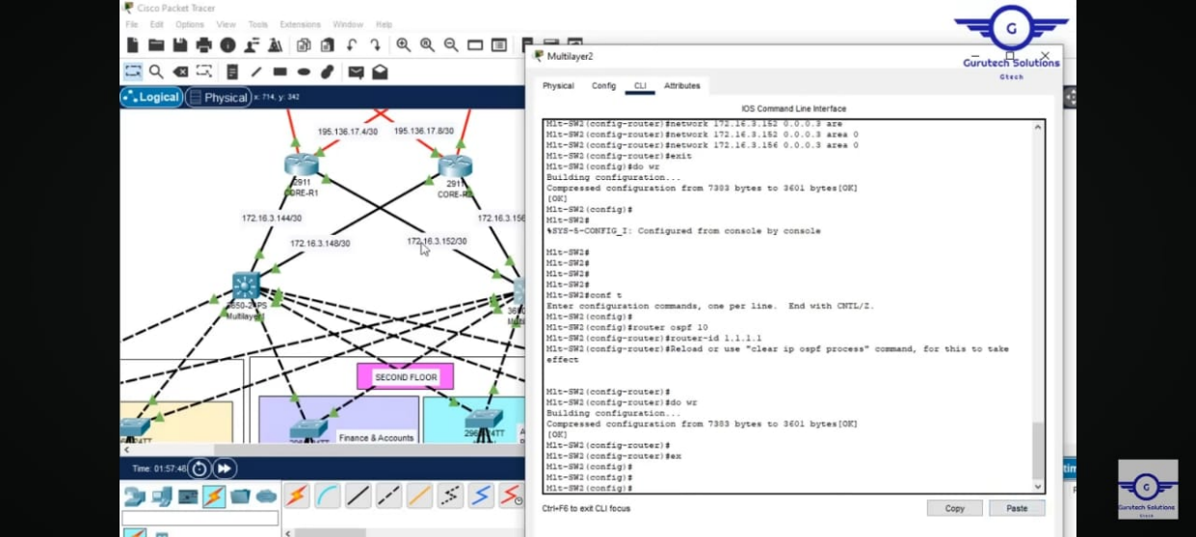

6. Static IP address to serverRoom devices.

7. DHCP server device configuratiuons.

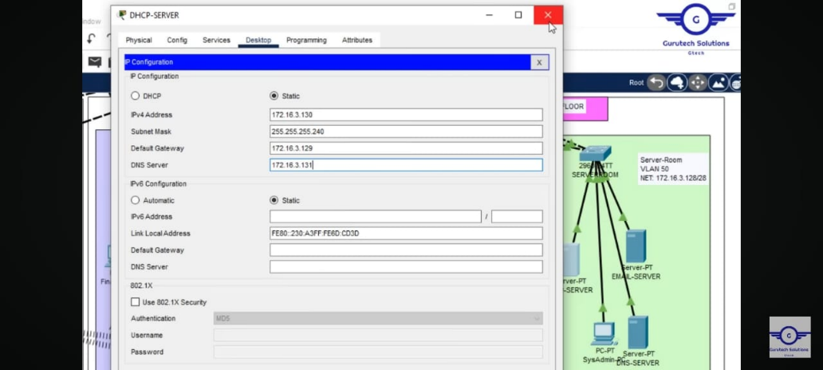

8. Inter-VLAN routing on the 13 switches plus ip dhcp helper addresses.

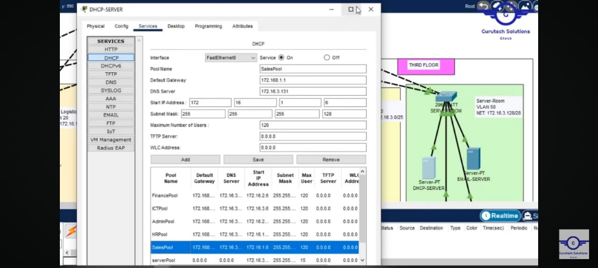

9. Wireless network configurations.

10. PAT + Access Control List

11. Verifying and testing configurations.

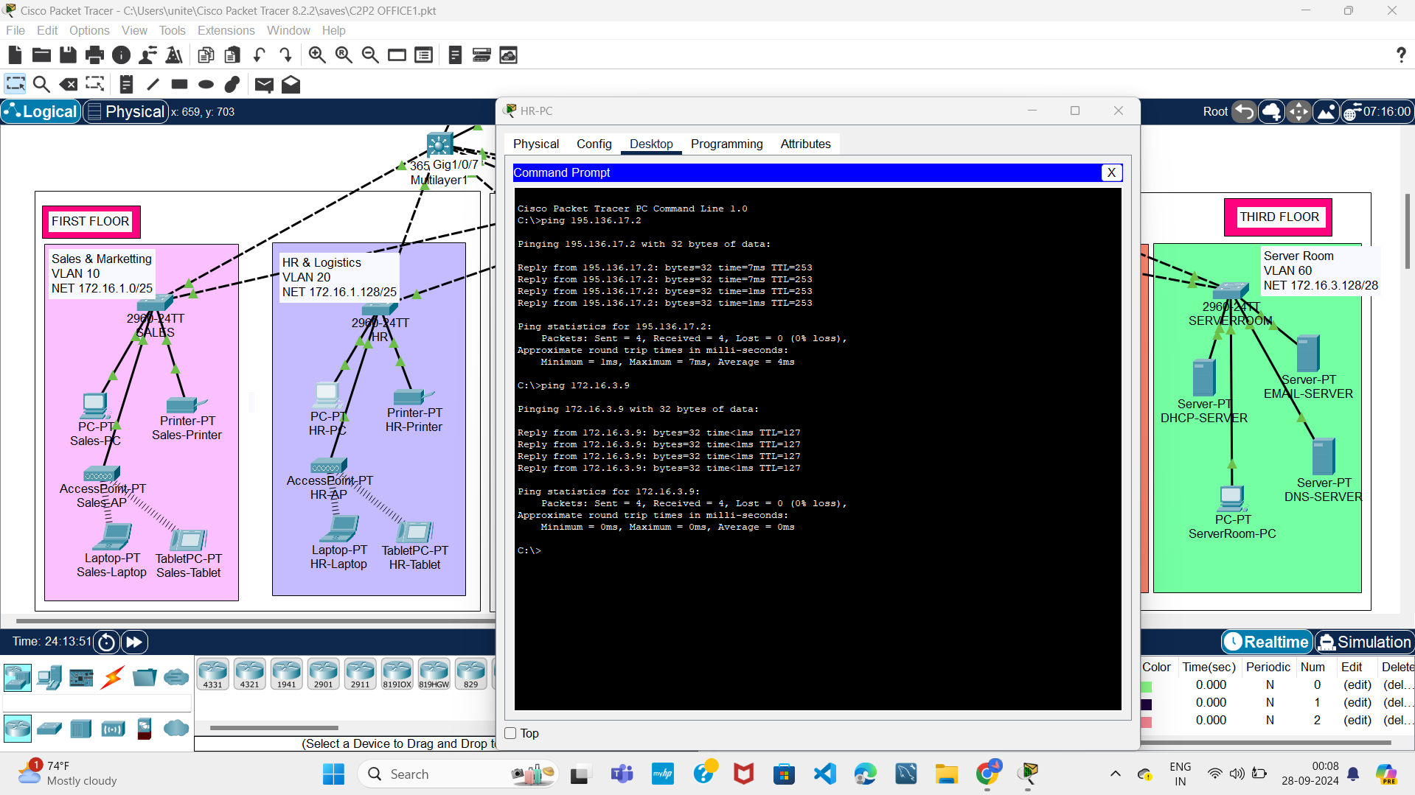

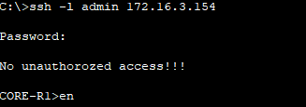

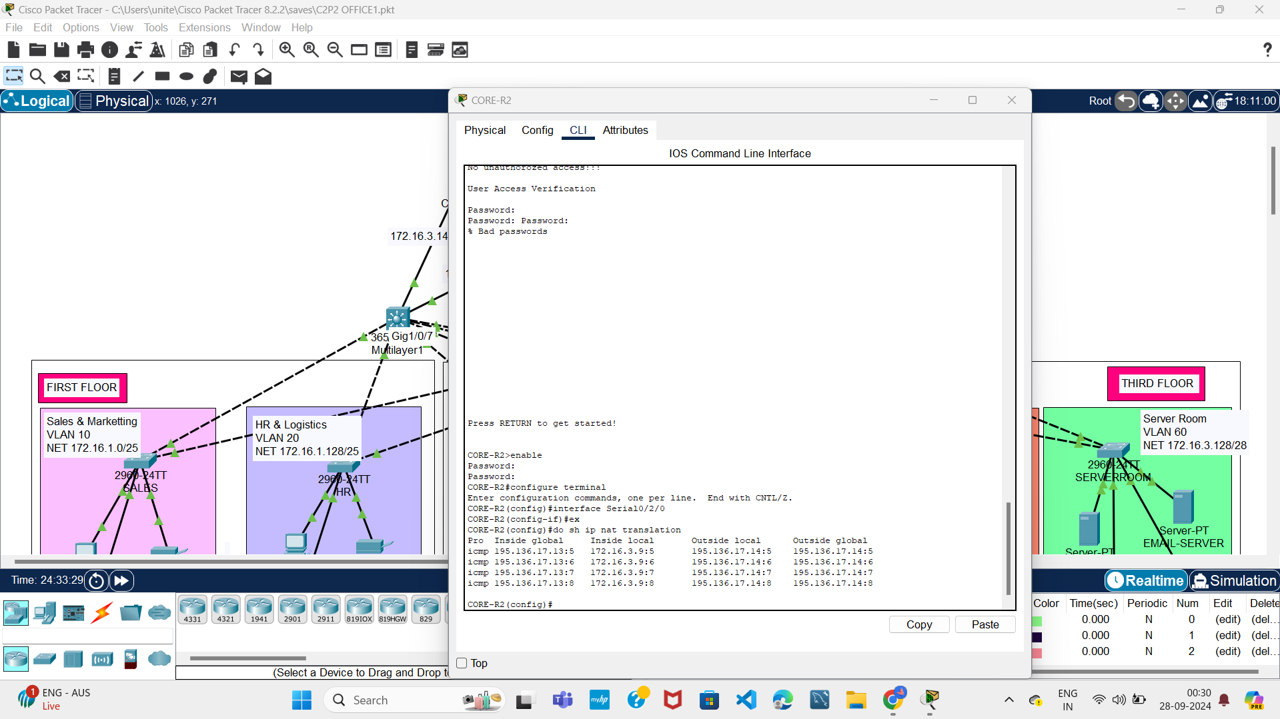

12. Firewall using ASA firewall.

**Cost Analysis Implementation:**

**A. Hardware Costs:**

* **Routers:** Cisco ISR 2900 (Qty: 2) = ₹2,00,000 each
* **Switches:** Cisco Catalyst 2960 (Qty: 5) = ₹75,000 each
* **Access Points:** Cisco Aironet 1800 (Qty: 5) = ₹40,000 each
* **Firewall:** Cisco ASA 5500 (Qty: 1) = ₹1,50,000
* **Cabling:** Approx. ₹100/meter (estimate length based on survey)
* **Network Racks:** ₹25,000 each (Qty: 2)
* **Servers:** Approx ₹4,00,000 for the server room infrastructure.

**B. Labour Costs:**

* **Installation and Setup:** ₹5,00,000 (approx. for installation, testing, and commissioning).
* **Maintenance Contract:** ₹2,00,000/year.

**C. Detailed Cost Breakdown:**

| **Item** | **Qty** | **Unit Price (₹)** | **Total Cost (₹)** |
| --- | --- | --- | --- |
| Cisco ISR Router | 2 | 2,00,000 | 4,00,000 |
| Cisco Catalyst Switch | 5 | 75,000 | 3,75,000 |
| Cisco Aironet AP | 5 | 40,000 | 2,00,000 |
| Cisco ASA Firewall | 1 | 1,50,000 | 1,50,000 |
| Cabling (approx. 2000m) | N/A | 100/m | 2,00,000 |
| Server Infrastructure | 1 | 4,00,000 | 4,00,000 |
| Network Racks | 2 | 25,000 | 50,000 |
| Installation & Setup | N/A |  | 5,00,000 |
| **Total Cost** |  |  | **22,75,000** |

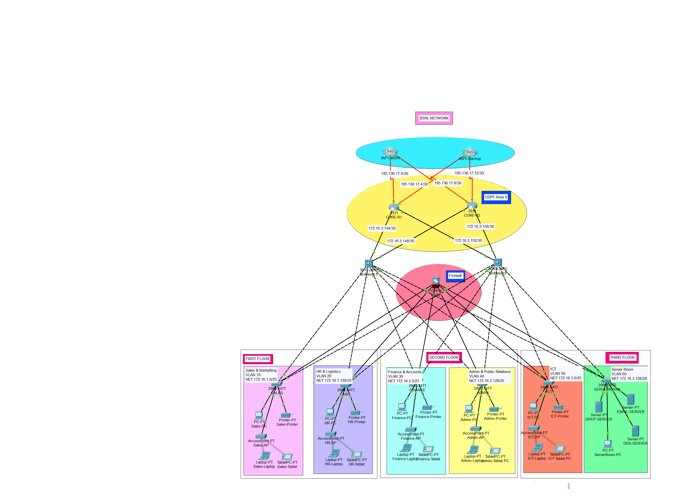

**1**Design and Implementation of a Local Area Network (LAN) for BSNL

**Conclusion:**

From this project, I learned the following key points:

* **Site Survey Importance:** Conducting a site survey helps identify optimal placements for networking devices, ensuring efficient coverage and reducing connectivity issues.
* **Network Design & Subnetting:** Designing a logical network topology and allocating IP addresses using subnetting is crucial for network efficiency, especially in a large organization like BSNL.
* **Cost Analysis:** Understanding the financial implications of hardware, installation, and ongoing maintenance is essential for creating a realistic budget for network infrastructure development.
* **Hands-on Network Configuration:** Using Cisco Packet Tracer, I gained practical experience in configuring switches, routers, and VLANs, which are essential skills for future network engineering roles.

This project enhanced my understanding of the entire network development process, from physical layout and device configuration to cost analysis and implementation.